SummAI: Automated Text Summarization for Business Insights
Problem Statement:
Janani, a business analyst, needs to efficiently extract key insights from large volumes of text data related to industry trends and competitor activities. To streamline this process, she requires an automated text summarization solution. The provided code, implementing extractive summarization techniques, serves as a foundation for developing a personalized tool tailored to Janani's needs. By automating the summarization process, the solution aims to enhance Janani's ability to make informed decisions and stay ahead of industry developments.
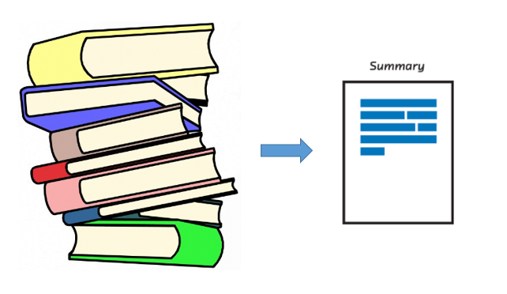

Pre-Requisites:
To complete this project, you must be required to download any one of the software.
- Anaconda Navigator: https://www.anaconda.com/anaconda-navigator (Jupyter notebook, Spyder)
- You can use any Python IDE
- Libraries to be installed are:
pip install pandas
pip install nltk
Objective:
The objective of SummAI is to streamline text summarization for business analysts like Janani, enabling efficient extraction of insights from large volumes of textual data to enhance decision-making and strategic planning.
Task:
- Importing libraries
- Stopwords and tokenizing
- Frequency table to keep the score of each word
- Summary
Solution Development Procedure:
Task 1: Importing libraries
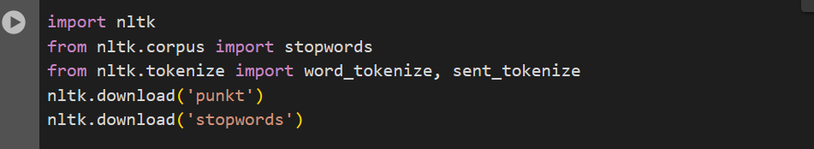
imported the required libraries.
Dataset: Own dataset
Importing necessary libraries like stopwords, punkt, sent_tikenize and word_tokenize.
Task 2: Stopwords and tokenizing
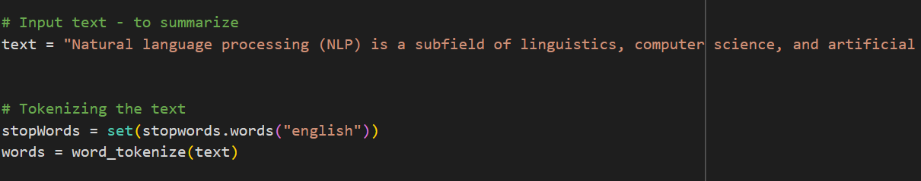
This code snippet tokenizes the input text into words using the NLTK library, a common step in natural language processing tasks. It then removes stopwords, which are common words like "is," "the," and "and," that typically do not convey significant meaning in text analysis. The resulting list of words can then be used for further text processing tasks such as frequency analysis, sentiment analysis, or in this case, text summarization. Tokenization and stopword removal are essential preprocessing steps in NLP that help streamline the analysis process by reducing noise and focusing on the most relevant information within the text.
Task 3: Frequency table to keep the score of each word
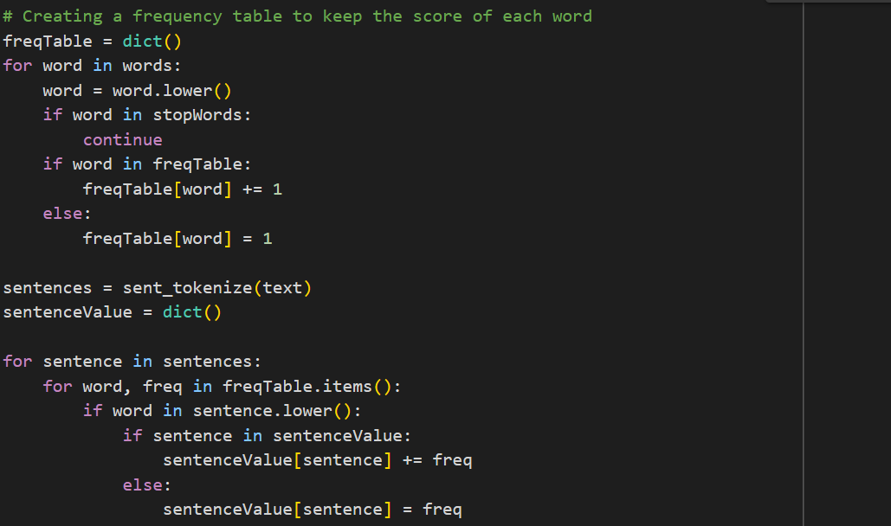
This code segment constructs a frequency table to keep track of the occurrence count of each word in the input text. It iterates over the list of words generated from tokenizing the text, converts each word to lowercase to ensure case insensitivity, and checks if the word is a stopword. If the word is not a stopword, it updates the frequency count in the frequency table. Subsequently, the code tokenizes the input text into sentences using NLTK's sentence tokenizer. For each sentence, it calculates the sentence value by summing the frequencies of the words present in the sentence based on the frequency table constructed earlier. This approach assigns higher values to sentences containing more frequent words, with the intention of identifying important sentences for text summarization based on their word frequency.
Task 4: Summary
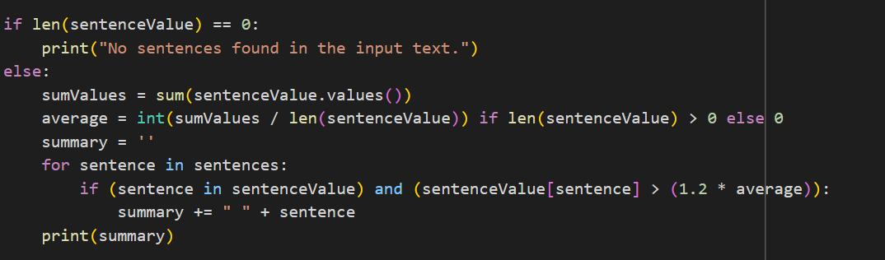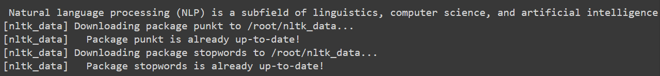
This paragraph serves to generate a summary of the input text based on the calculated sentence values. It begins by checking if there are any sentences in the input text. If no sentences are found, it prints a message indicating that no sentences were detected. However, if sentences are present, it proceeds to calculate the average sentence value by summing the values of all sentences and dividing by the total number of sentences. Next, it iterates through each sentence in the input text and checks if the sentence's value exceeds 1.2 times the average sentence value. If the condition is met, the sentence is considered significant and appended to the summary. Finally, the generated summary is printed. This summarization approach aims to select sentences with higher-than-average importance scores, which are likely to contain key information for summarizing the text.
Conclusion
"SummAI" leverages extractive summarization techniques to empower business analysts like Janani with efficient text summarization capabilities, enabling them to distill key insights from large volumes of textual data effortlessly. By automating the summarization process, SummAI enhances decision-making and strategic planning, ensuring professionals stay informed and agile in dynamic business environments.

